Exercise 1: Downloading and Installing R and RStudio

# Assignment:

For this first exercise, make sure that you can download and install R and RStudio successfully on your computer. Refer back to “Video 3: Preparing Workspace” for the detailed video on how to install R and RStudio. Below are screenshots to help you along the way.

# Step 1:

Navigate to [R’s](https://www.r-project.org/) and [RStudio’s](https://www.rstudio.com/) websites. You can either type them into your preferred search engine or follow the links.

# Installing R:

## Step 2:

Click on “download R” under Getting started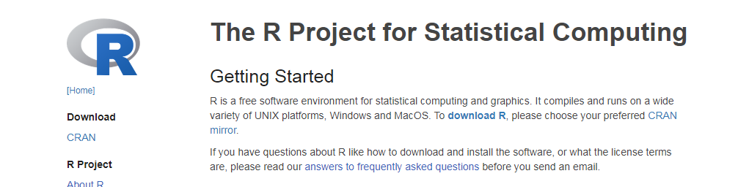



## Step 3:

Find your appropriate CRAN mirror, the one that is closest to you geographically.

## Step 4:

Click Download R for ______ (your operating system).

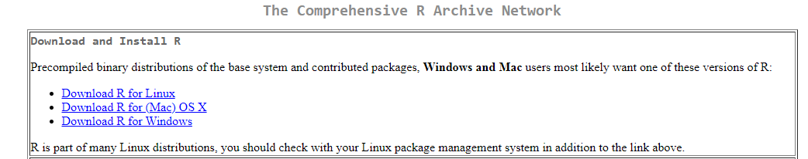

## Step 5:

Click on the option for “base” R or click “install R for the first time” 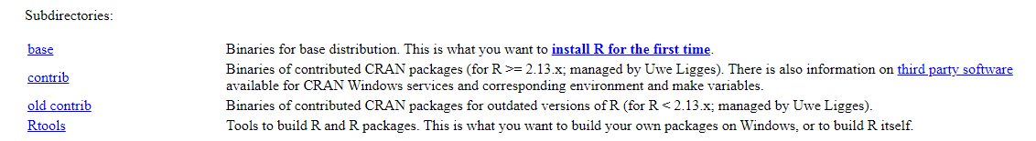





## Step 6:

Click Download R [current version #] for [your operating system]. You want the most current version they have, so don’t go searching for 4.0.5 in the archives. Everything that is done in this course can be done with version 4.0.5 or any later version as they just add on features. 

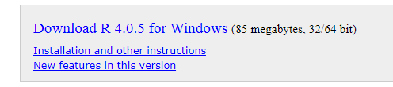

## Step 7:

Click on the .exe file and follow your operating system’s installer prompts to correctly download R.

If you have any questions you can visit the R FAQ page.

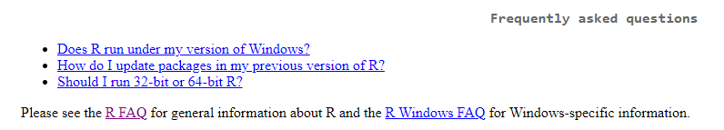

# Installing RStudio:

## Step 8:

Navigate to the [RStudio](https://www.rstudio.com/) website. 

## Step 9:

Hover your mouse over products, then click on RStudio on the left side of the dropdown menu.

## Step 10:

Scroll down to where you see RStudio Desktop - Open Source Edition, and click on “Download RStudio Desktop.

## Step 11:

Scroll down to where it says Download for the Free desktop version, and click on “Download” 

## Step 12:

Click on Download Rstudio for [Your Operating System]. The RStudio website is smart and detects which operating system you are currently working on and will give you the recommended installation version. 

## Step 13:

Click on the .exe file and follow the instructions given by your operating system’s installation wizard. If you experience any issues with installation, you can visit [RStudio’s Support](https://www.rstudio.com/support/) page.

# Finished!

Once you are all set up with installing both programs, give yourself a pat on the back, you have finished your first section of the course! Way to go!